Week 07

Question 1:
Sunny and Johnny like to pool their money and go to the ice cream parlor. Johnny never buys the same flavor that Sunny does. The only other rule they have is that they spend all of their money. Given a list of prices for the flavors of ice cream, select the two that will cost all of the money they have. For example, they have m = 6 to spend and there are flavors costing cost = [1, 2, 3, 4, 5, 6]. The two flavors costing 1 and 5 meet the criteria. Using 1-based indexing, they are at indices 1 and 4.
Input Format:
The first line contains an integer, t, denoting the number of trips to the ice cream parlor. The next t sets of lines each describe a visit. Each trip is described as follows:
1. The integer m, the amount of money they have pooled.
2. The integer n, the number of flavors offered at the time.
3. n space-separated integers denoting the cost of each flavor: cost[cost[1], cost[2], . . . , cost[n]].
Output Format: For each test case, print two space-separated integers denoting the indices of the two flavors purchased, in ascending order.
Program:

Output:
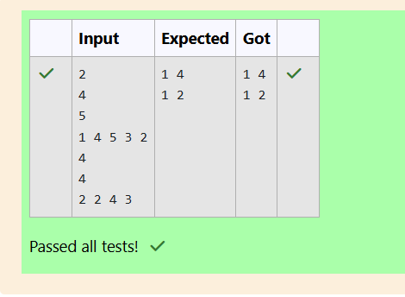

Question 2:
Numeros the Artist had two lists that were permutations of one another. He was very proud. Unfortunately, while transporting them from one exhibition to another, some numbers were lost out of the first list. Can you find the missing numbers? As an example, the array with some numbers missing, arr = [7, 2, 5, 3, 5, 3]. The original array of numbers brr = [7, 2, 5, 4, 6, 3, 5, 3]. The numbers missing are [4, 6].
Input Format:
There will be four lines of input:
n - the size of the first list, arr
The next line contains n space-separated integers arr[i]
m - the size of the second list, brr
The next line contains m space-separated integers brr[i]
Output Format
Output the missing numbers in ascending order.
Program:
Output:
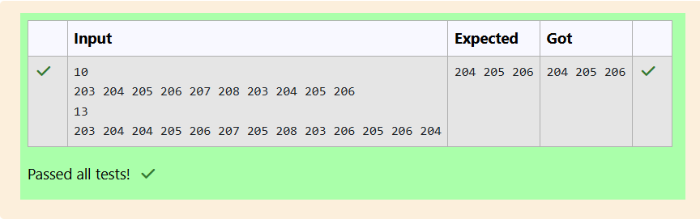

Question 3:
Watson gives Sherlock an array of integers. His challenge is to find an element of the array such that the sum of all elements to the left is equal to the sum of all elements to the right. For instance, given the array arr = [5, 6, 8, 11], 8 is between two subarrays that sum to 11. If your starting array is [1], that element satisfies the rule as left and right sum to 0. You will be given arrays of integers and must determine whether there is an element that meets the criterion. Complete the code in the editor below. It should return a string, either YES if there is an element meeting the criterion or NO otherwise.
Input Format:
The first line contains T, the number of test cases.
The next T pairs of lines each represent a test case.
- The first line contains n, the number of elements in the array arr.
- The second line contains n space-separated integers arr[i] where 0 ≤ i < n.
Output Format:
For each test case print YES if there exists an element in the array, such that the sum of the elements on its left is equal to the sum of the elements on its right; otherwise print NO.
Program:

Output:
